MQTT project
  - Mark Saleh, 103994313

P level
Here are instructions explaining how to the applications “mqtt post.py” and “mqtt subscribe.py”:
- Download the two python files
- Install python 3.11 from online if you do not already have it, and add it to your path variable. Also install paho by typing ‘pip install paho-mqtt’ in the terminal or command prompt
- Open “mqtt subscribe.py” and run it in VSCode using Ctrl+Alt+N, or the little triangle logo in the top right corner
- Open “mqqt post.py” and run it the same way. You should see the messages it posts appear on the terminal for “mqqt subscribe.py” like this:
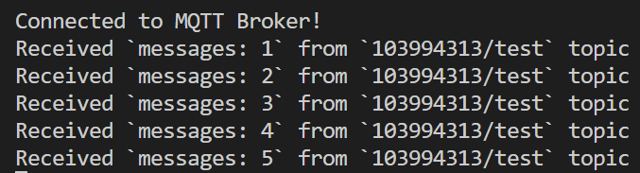
- To observe this in a graphical MQTT client, install MQTTX. Open it and establish a connection like this:
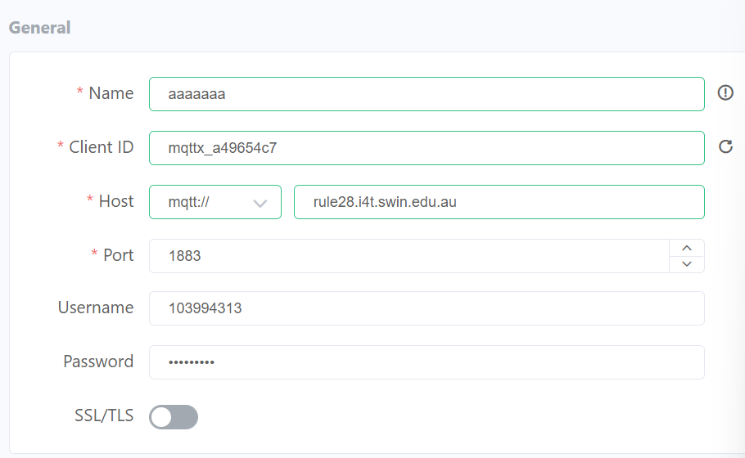
(Note that the password is the same as the username)
- Once there, click on “New subscription” and, under “topic”, type “103994313/#”. Click “confirm”. If you want to, you may also subscribe to “public/#”
- Run “mqtt post.py” again and you should see its posts in MQTTX like this:
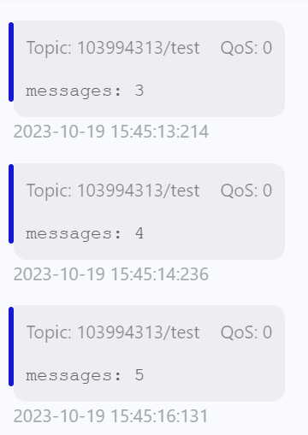
- Also, post anything in either 103994313 or public, and it should appear in the terminal for “mqtt subscribe.py”
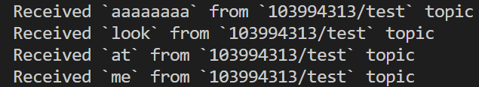
Here is the code of mqtt post.py:
import paho.mqtt.client as mqtt_client
import random
import time

broker = 'rule28.i4t.swin.edu.au'
port = 1883
topic = "103994313/test"
# Generate a Client ID with the publish prefix.
client_id = f'publish-{random.randint(0, 1000)}'
username = '103994313'
password = '103994313'

def connect_mqtt():
def on_connect(client, userdata, flags, rc):
if rc == 0:
print("Connected to MQTT Broker!")
else:
print("Failed to connect, return code %d\n", rc)
client = mqtt_client.Client(client_id)
client.username_pw_set(username, password)
client.on_connect = on_connect
client.connect(broker, port)
return client

def publish(client):
msg_count = 1
while True:
time.sleep(1)
msg = f"messages: {msg_count}"
result = client.publish(topic, msg)
# result: [0, 1]
status = result[0]
if status == 0:
print(f"Sent `{msg}` to topic `{topic}`")
else:
print(f"Failed to send message to topic {topic}")
msg_count += 1
if msg_count > 5:
break

def run():
client = connect_mqtt()
client.loop_start()
publish(client)
client.loop_stop()

if __name__ == '__main__':
run()
and here is mqtt subscribe.py:
import random
from paho.mqtt import client as mqtt_client

broker = 'rule28.i4t.swin.edu.au'
port = 1883
topic1 = "103994313/#"
topic2 = "public/#"
# Generate a Client ID with the subscribe prefix.
client_id = f'subscribe-{random.randint(0, 100)}'
username = '103994313'
password = '103994313'

def connect_mqtt() -> mqtt_client:
def on_connect(client, userdata, flags, rc):
if rc == 0:
print("Connected to MQTT Broker!")
else:
print("Failed to connect, return code %d\n", rc)

client = mqtt_client.Client(client_id)
client.username_pw_set(username, password)
client.on_connect = on_connect
client.connect(broker, port)
return client

def subscribe(client: mqtt_client):
def on_message(client, userdata, msg):
print(f"Received `{msg.payload.decode()}` from `{msg.topic}` topic")
client.subscribe(topic1)
#client.subscribe(topic2)
client.on_message = on_message

def run():
client = connect_mqtt()
subscribe(client)
client.loop_forever()

if __name__ == '__main__':
run()

C level
To achieve a C level, I modified mqtt post.py so that it also subscribes to the private and public topics, and (like mqtt subscribe.py), prints any post it gets along with which topic it received it from. It also posts to both the private and public topics. In this way I achieved not only the C-level requirements but also two of the three D level ones. Here is the cybersecurity report required for a C:

Introduction
This cybersecurity report outlines the security issues with the current deployment of the MQTT broker

Findings
- The username and password system, which allows access to private topics, is a security risk as the username, password and private topic are all identical, making them easy to guess and thus vulnerable to attack. It is recommended to make them different, and perhaps use two-factor authentication for added security.
- Data exchanged within the MQTT broker is not encrypted, which allows it to be intercepted and read. It is recommended to implement Transport Layer Security (TLS).
- The public channel serves its purpose but poses security concerns due to its availability. Furthermore, the fact that every device is subscribed to it is an additional risk since to leaves these devices vulnerable to DDoS attacks. It is recommended to decrease the system’s reliance on the public topic, instead utilising subtopics and private topics.
- There is currently no filtering system for outbound traffic. It is recommended to add one in order to detect and filter unusual traffic, which could be malicious.

Conclusion
The MQTT broker plays a pivotal role in our infrastructure, but is currently not as secure as it should be. It should be protected from cyberattack by making its passwords harder to guess, implementing an encryption mechanism such as TLS or SSL, decreasing its reliance on the public topic and implementing outbound traffic inspection.

